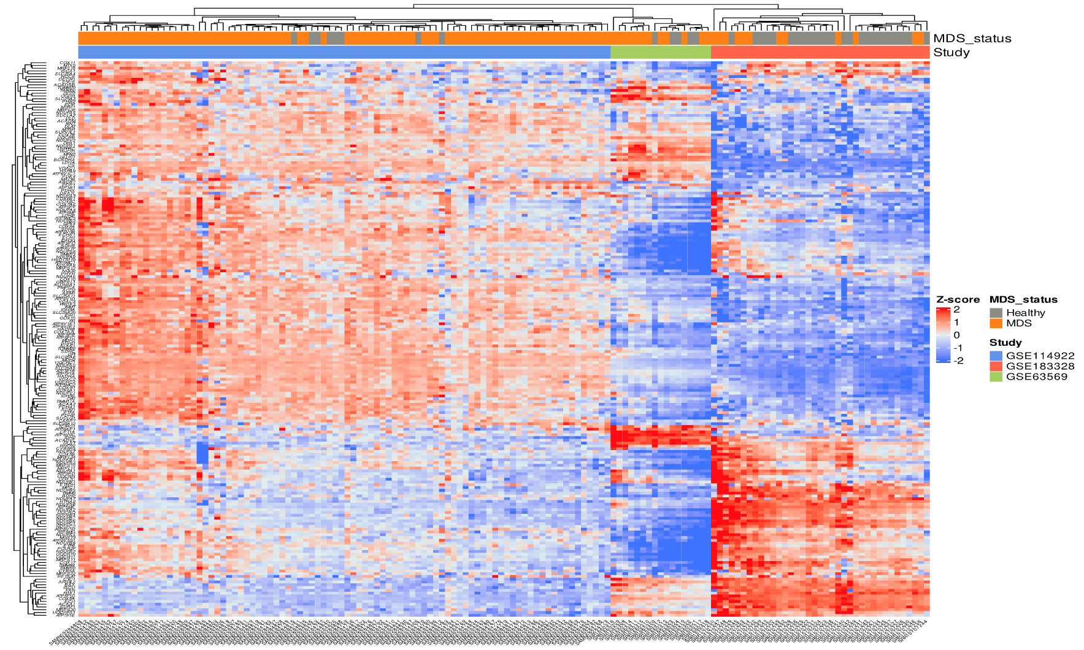
Supplementary Fig. 1. Identified MDS vs. healthy individuals gene sets of OXPHOS pathway among independent multiple MDS cohorts. The heatmap shows the discrimination of patients with MDS vs. healthy individuals based on the topmost enriched gene sets in the OXPHOS pathway.

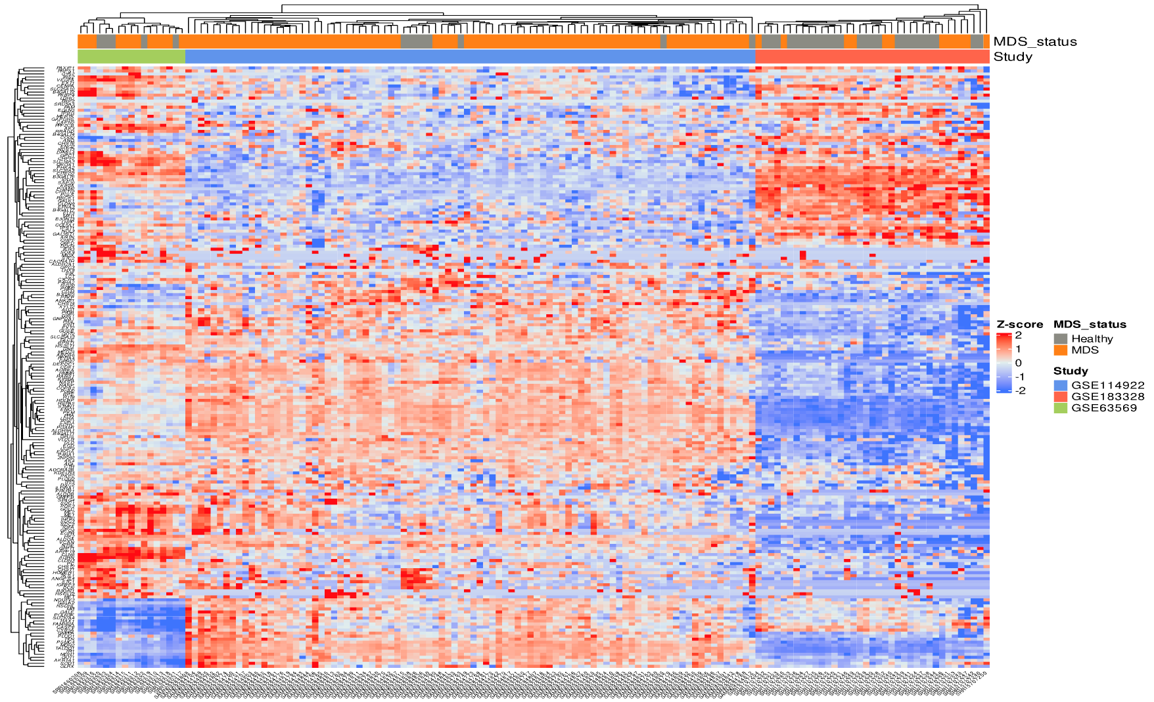
Supplementary Fig. 2. Identified MDS vs. healthy individuals gene sets of glycolysis pathway among independent multiple MDS cohorts. The heatmap shows the discrimination of patients with MDS vs. healthy individuals based on the topmost enriched gene sets in the glycolysis pathway.

Supplementary Table 1. Mutual exclusivity observed among MDS patients with specific genetic alterations.
A | B | Neither | A Not B | B Not A | Both | p-Value | Tendency
SRSF2 | DNMT3A | 3026 | 379 | 816 | 39 | <0.001 | Mutual exclusivity
ASXL1 | DNMT3A | 3014 | 391 | 810 | 45 | <0.001 | Mutual exclusivity
JAK2 | DNMT3A | 3110 | 295 | 814 | 41 | <0.001 | Mutual exclusivity
TP53 | DNMT3A | 3063 | 342 | 796 | 59 | 0.002 | Mutual exclusivity
TET2 | DNMT3A | 2839 | 566 | 730 | 125 | 0.161 | Mutual exclusivity

Supplementary Table 2. The current ongoing clinical trials targeting metabolic pathways associated with mutated genes in MDS and myeloid leukemias. The table summarizes the list of recruiting clinical trials focused on targeted biological processes (according to https://clinicaltrials.gov, retrieved on the 14th of August, 2023).
NCT Number | Study Status | Conditions | Targeted Biological Process | Interventions/Drugs/Procedure
NCT04493164 | Recruiting | MDS/AML | Mutant IDH1 Inhibitor | Ivosidenib/Liposome-encapsulated Daunorubicin-Cytarabine
NCT03503409 | Recruiting | MDS/AML | Mutant IDH1 Inhibitor | AG-120
NCT03744390 | Recruiting | MDS/AML | Mutant IDH2 Inhibitor | AG-221
NCT04827719 | Recruiting | MDS/AML | High-dose cytarabine delivery | BST-236
NCT04279847 | Recruiting | MDS | BET inhibitor and JAK inhibitor | INCB057643/Ruxolitinib
NCT04140487 | Recruiting | MDS/AML | FLT3 tyrosine kinase inhibitors and DNA Methylation and synthesis Inhibitor | Azacitidine/Gilteritinib/Venetoclax
NCT05010122 | Recruiting | MDS/AML | FLT3 tyrosine kinase inhibitor and DNMT1 Inhibitor | Decitabine and Cedazuridine/Gilteritinib/Venetoclax
NCT03661307 | Recruiting | MDS/AML | DNMT1 Inhibitor and FLT3 tyrosine kinase inhibitor | Decitabine/Quizartinib/Venetoclax
NCT03683433 | Recruiting | MDS/AML/CML | DNA Methylation and synthesis Inhibitor and Mutant IDH Inhibitor | Azacitidine/Enasidenib Mesylate
NCT05636514 | Recruiting | MDS/AML/CML | FLT3 tyrosine kinase inhibitor and FAK inhibitor | Decitabine-Cedazuridine 35 Mg-100 Mg ORAL TABLET/Defactinib
NCT04493138 | Recruiting | MDS/CML | DNMT1 Inhibitor and FLT3 tyrosine kinase inhibitor | Azacitidine/Quizartinib
NCT05817955 | Recruiting | MDS | DNA Methylation and synthesis Inhibitor and JAK Inhibitor | Azacitidine (AZA) with Ruxolitinib
NCT04803721 | Recruiting | MDS
NCT04250051 | Recruiting | MDS/AML | Mutant IDH1 Inhibitor | Cytarabine/Filgrastim/Fludarabine/Fludarabine Phosphate/Ivosidenib
NCT04167917 | Recruiting | MDS/AML/CML | DNA methyltransferase 1 (DNMT1) inhibition | NTX-301
NCT04187703 | Recruiting | MDS | DNA methyltransferase (DNMT) inhibition | 5-azacytidine/Decitabine
NCT05282459 | Recruiting | MDS | Mutant IDH2 Inhibitor | Enasidenib mesylat dose escalation
NCT04741945 | Recruiting | MDS | Antihyperglycemic | Metformin
NCT04477291 | Recruiting | MDS/AML | FLT3 Inhibitor | CG-806
NCT03839771 | Recruiting | MDS/AML | Mutant IDH1 Inhibitor and Mutant IDH2 Inhibitor | AG-120/Placebo for AG-120/AG-221/Placebo for AG-221
NCT05030675 | Recruiting | MDS/CML | Tyrosine kinase inhibitor | Fostamatinib
NCT03953898 | Recruiting | MDS/AML | poly (ADP-ribose) polymerase (PARP) inhibitor | Biospecimen Collection/Bone Marrow Aspiration/Olaparib
NCT03999723 | Recruiting | MDS/AML/CML |  | Vitamin C/Placebo
NCT04764474 | Recruiting | Hematological Malignancies With IDH mutations | Mutant IDH1/2 Inhibitor | HMPL-306

